ADMIN: admin@coach360.com / secret
LINK: https://ismaellunas.github.io/optim8-coach360/
—---

E3-T1

BUG: No logo appears when editing a team with a logo

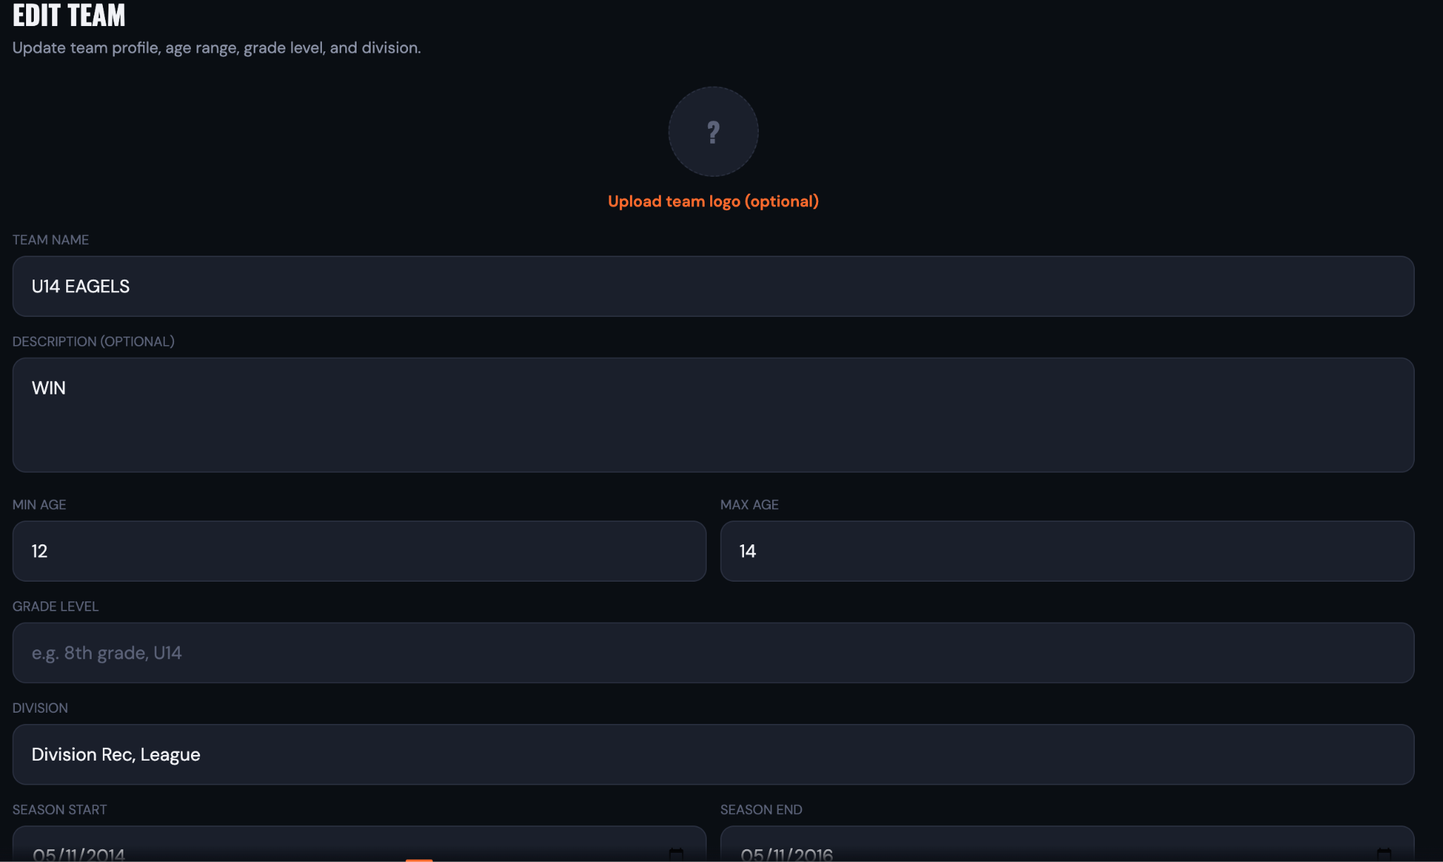

TEST ID: E4-T4
BUG: NOT ABLE UPGRDE TO PRO
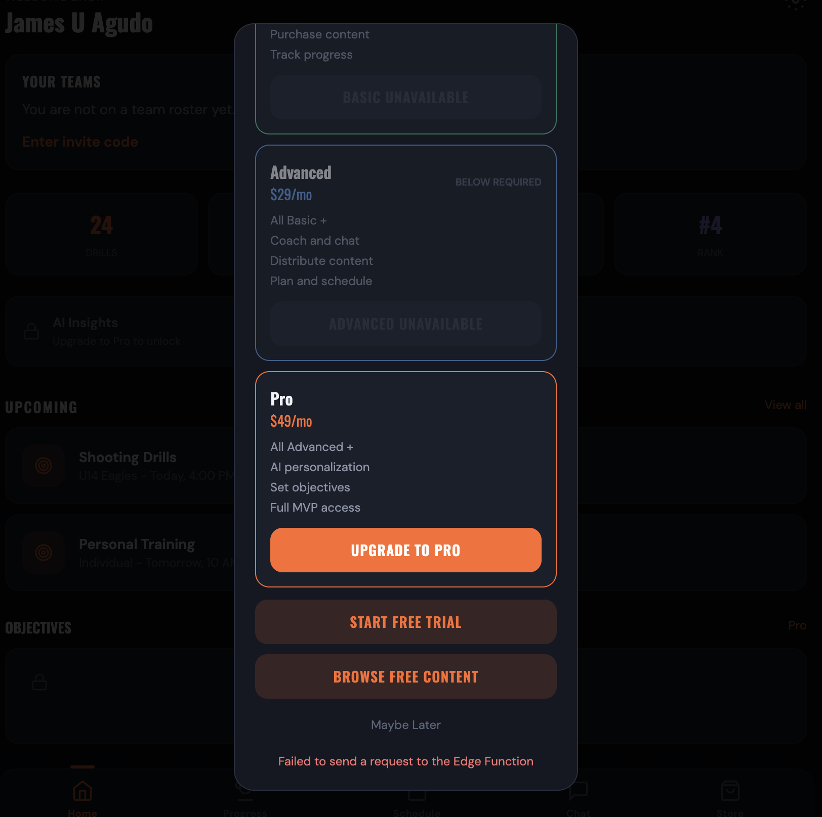

TEST ID: E4-T6
BUD: NOT ABLE TO UPGRADE TO ADVANCED
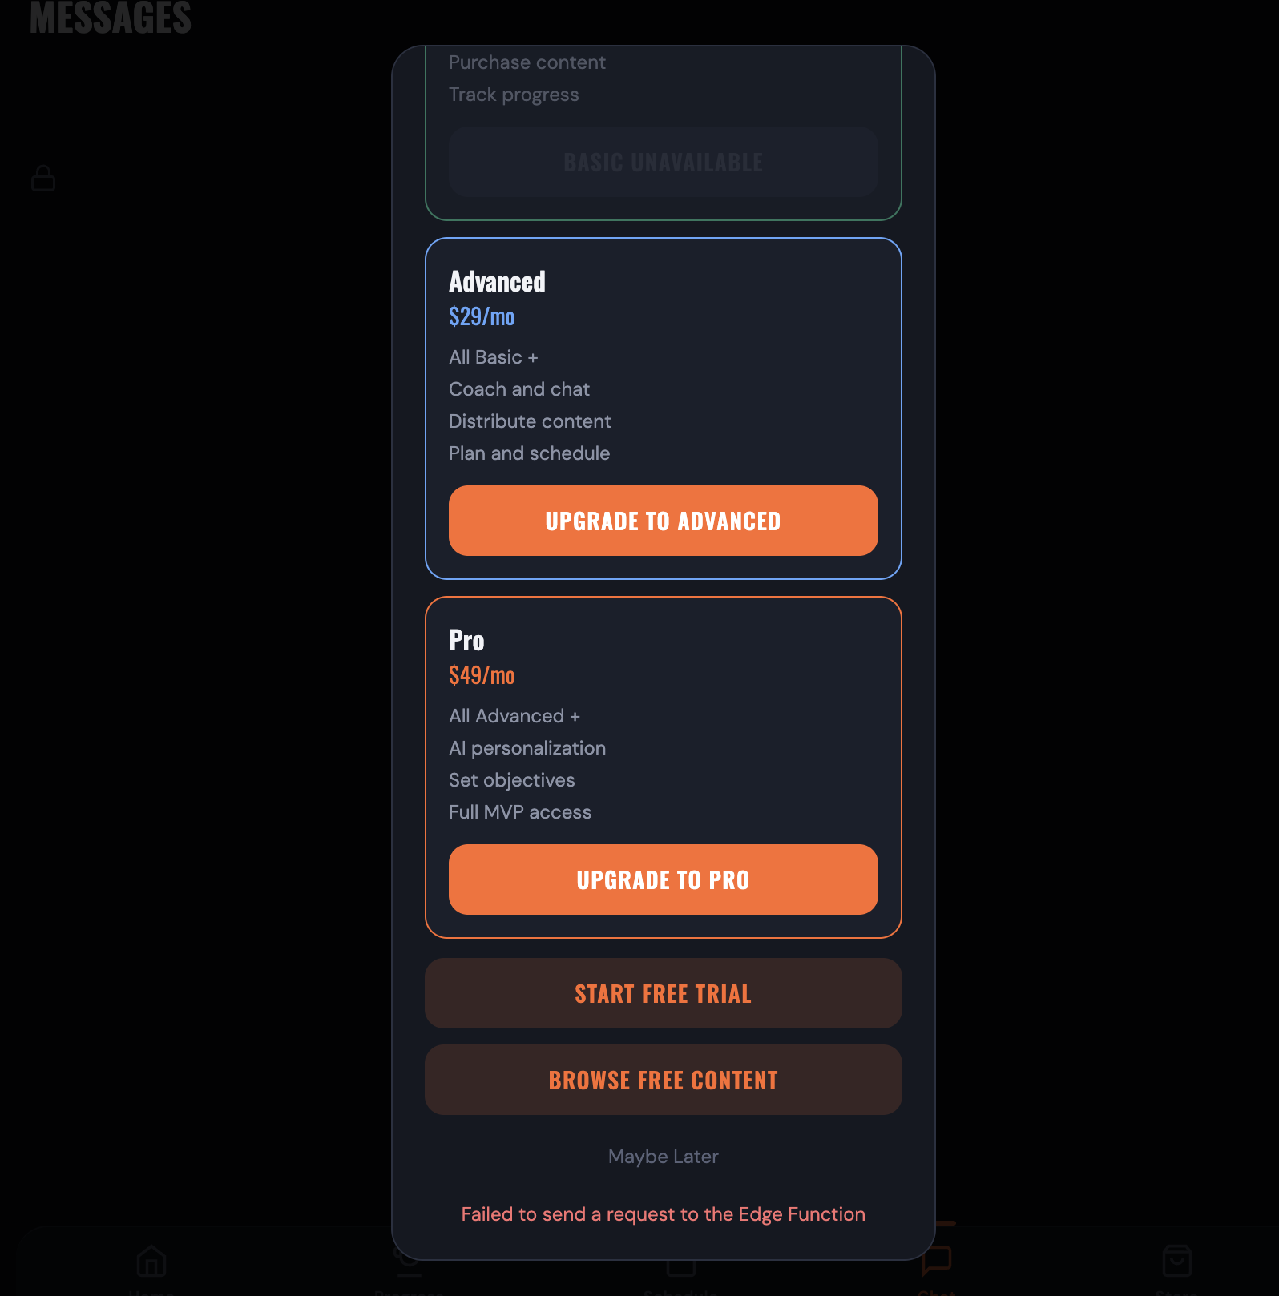

TEST ID: E4-T7
BUG:NOT ABLE TO UPGRADE TO ADVANCED

TEST ID: E4-T8
BUG: UPGRADE DID NOT WORKED

TEST ID: E4-T9
BUG: REGISTER WITH PRO BUT FOUND BASIC IN MANAGE SUBCRIPTION
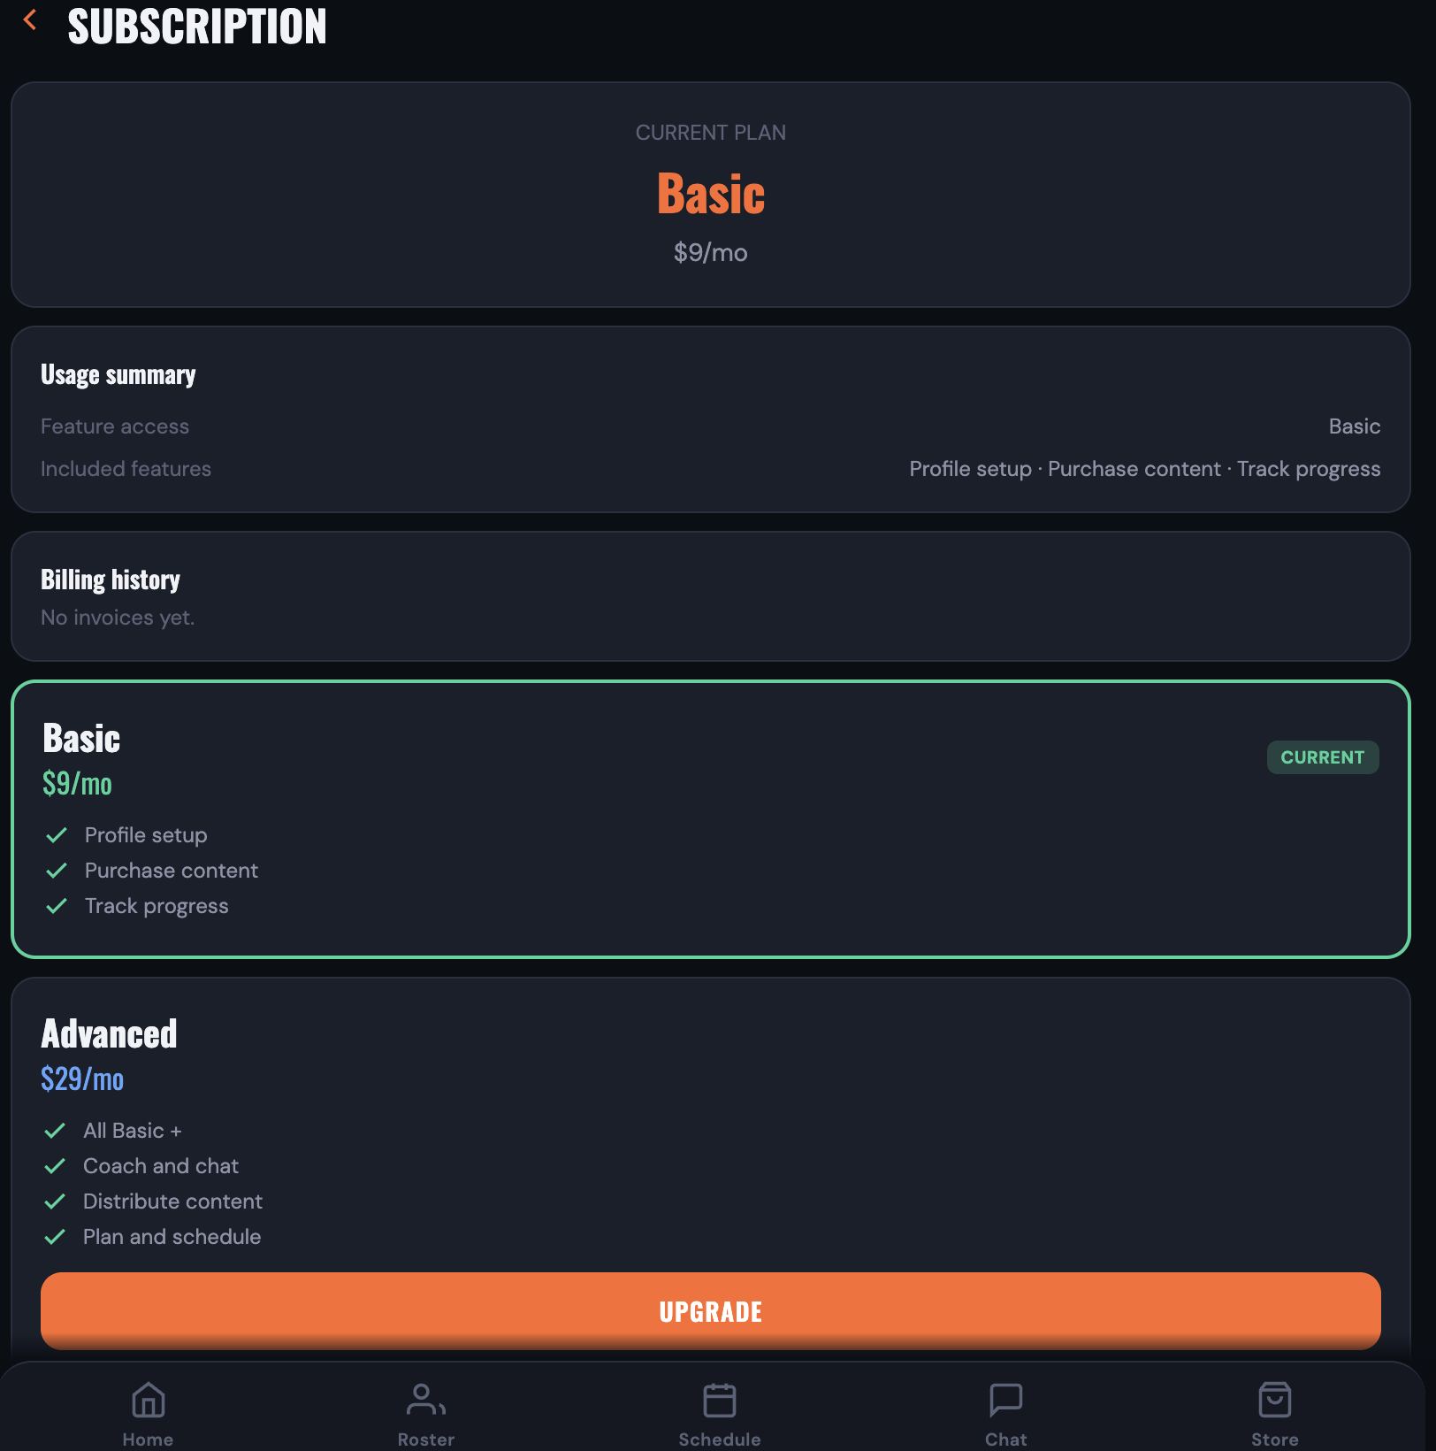

TEST ID: E5-T6
BUG: UPGRADE BUG
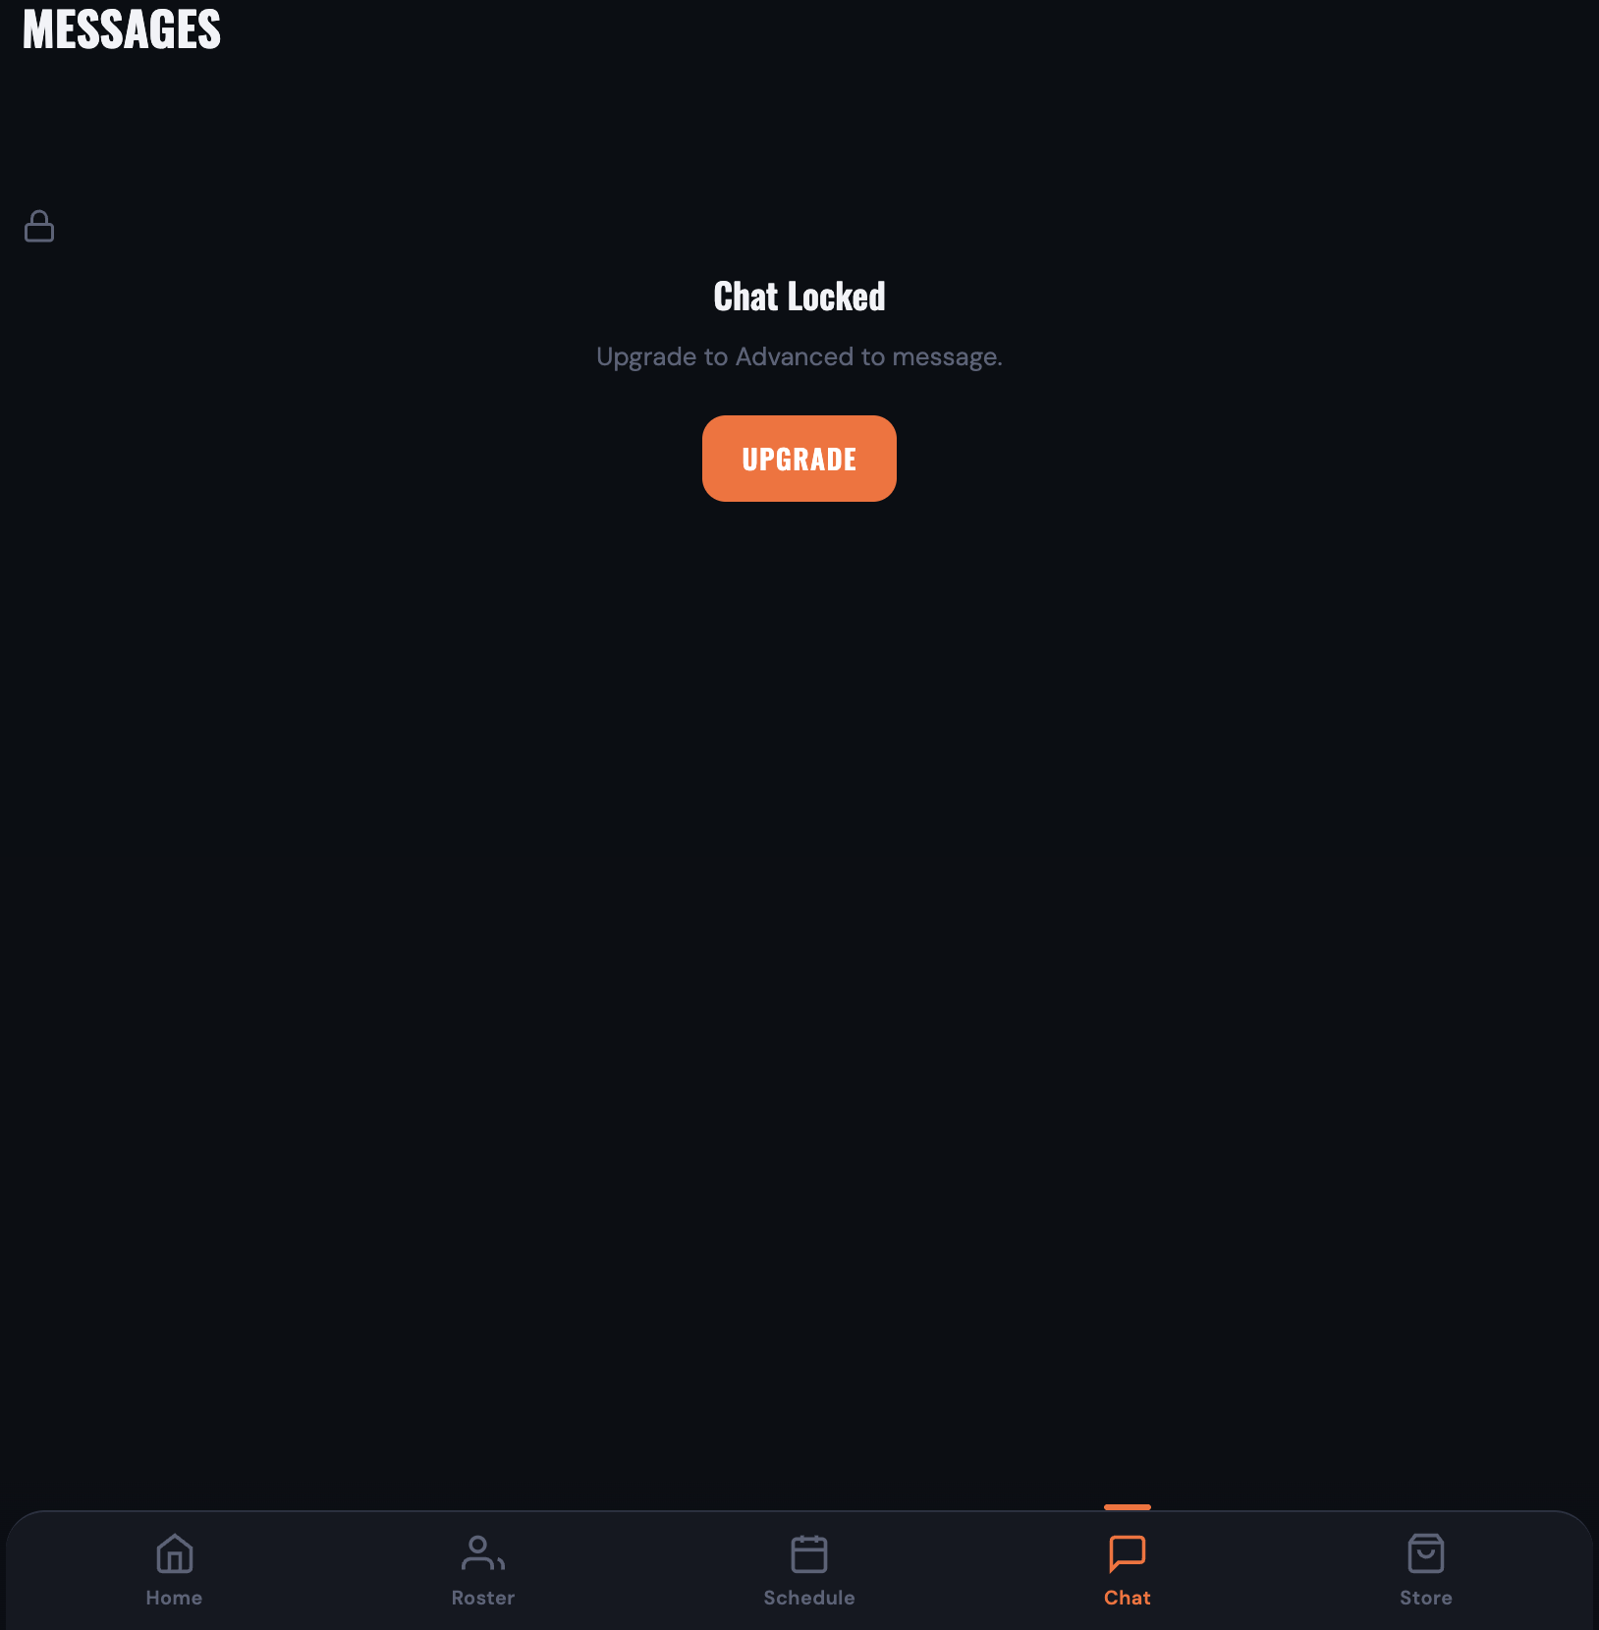

TEST ID: E5-T7
BUG: IT DID NOT OPEN AI INSIGHTS
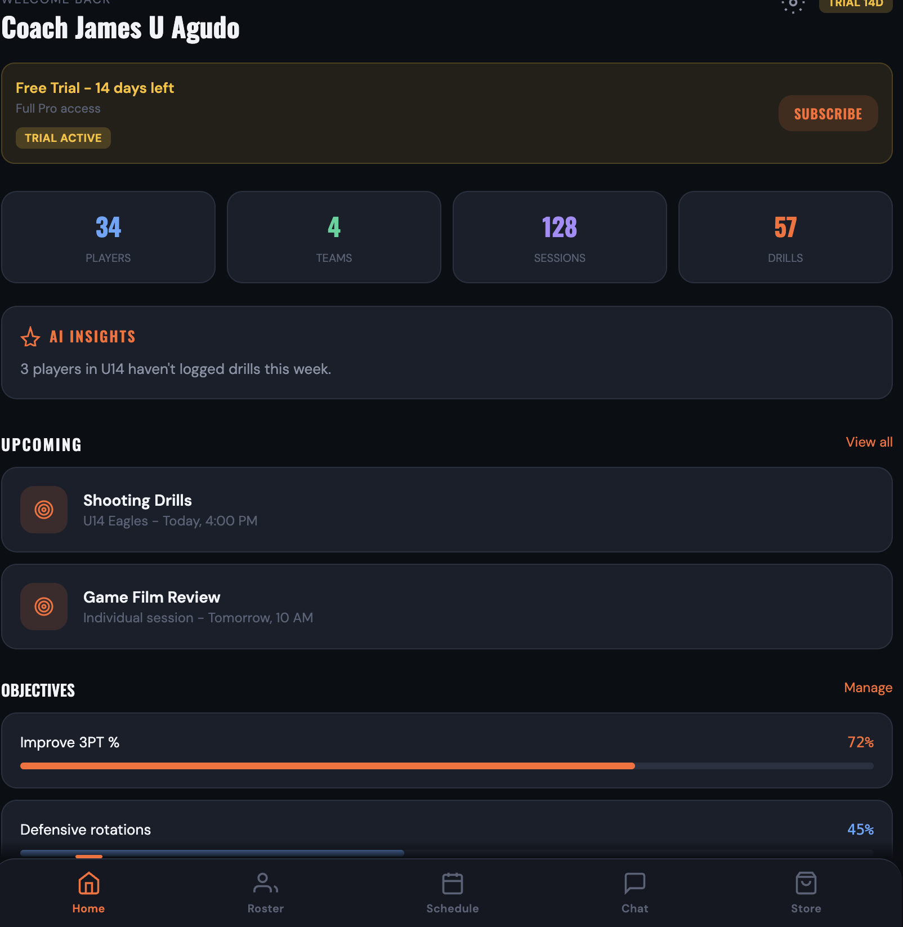

TEST ID: E5-T8
BUG: THE OBJECTIVES CANNOT OPEN
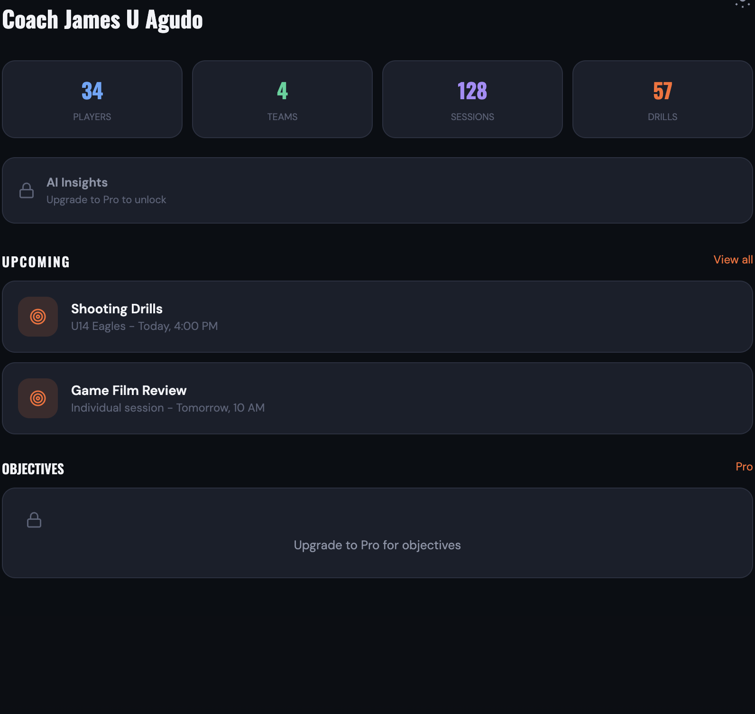

TEST ID: E8-T8
BUG: CANNOT POST TO A TEAM CHAT
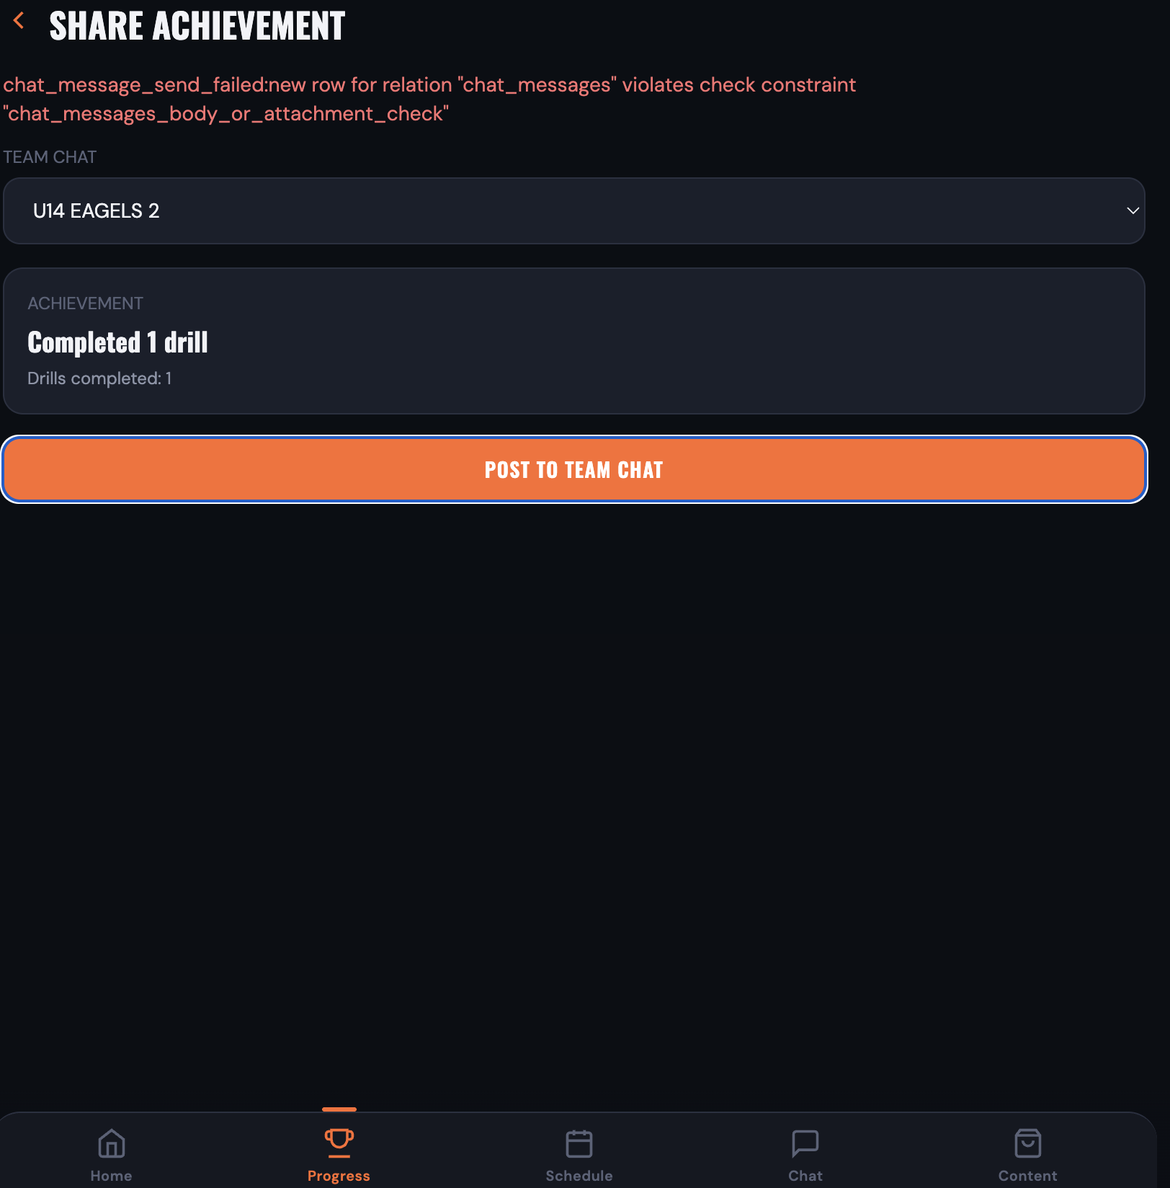
TEAM ID: E10-T9
BUG: Admin approves or rejects a coach submission (STORY-10.4 AC-2 / AC-4)

*Needs Admin dashboard access and a Training package in Sanity set to Pending review (Workflow status), with Created by = Coach and optionally a Suggested price. Ensure the package has synced into package_metadata (save/publish the Sanity document so the webhook runs).*

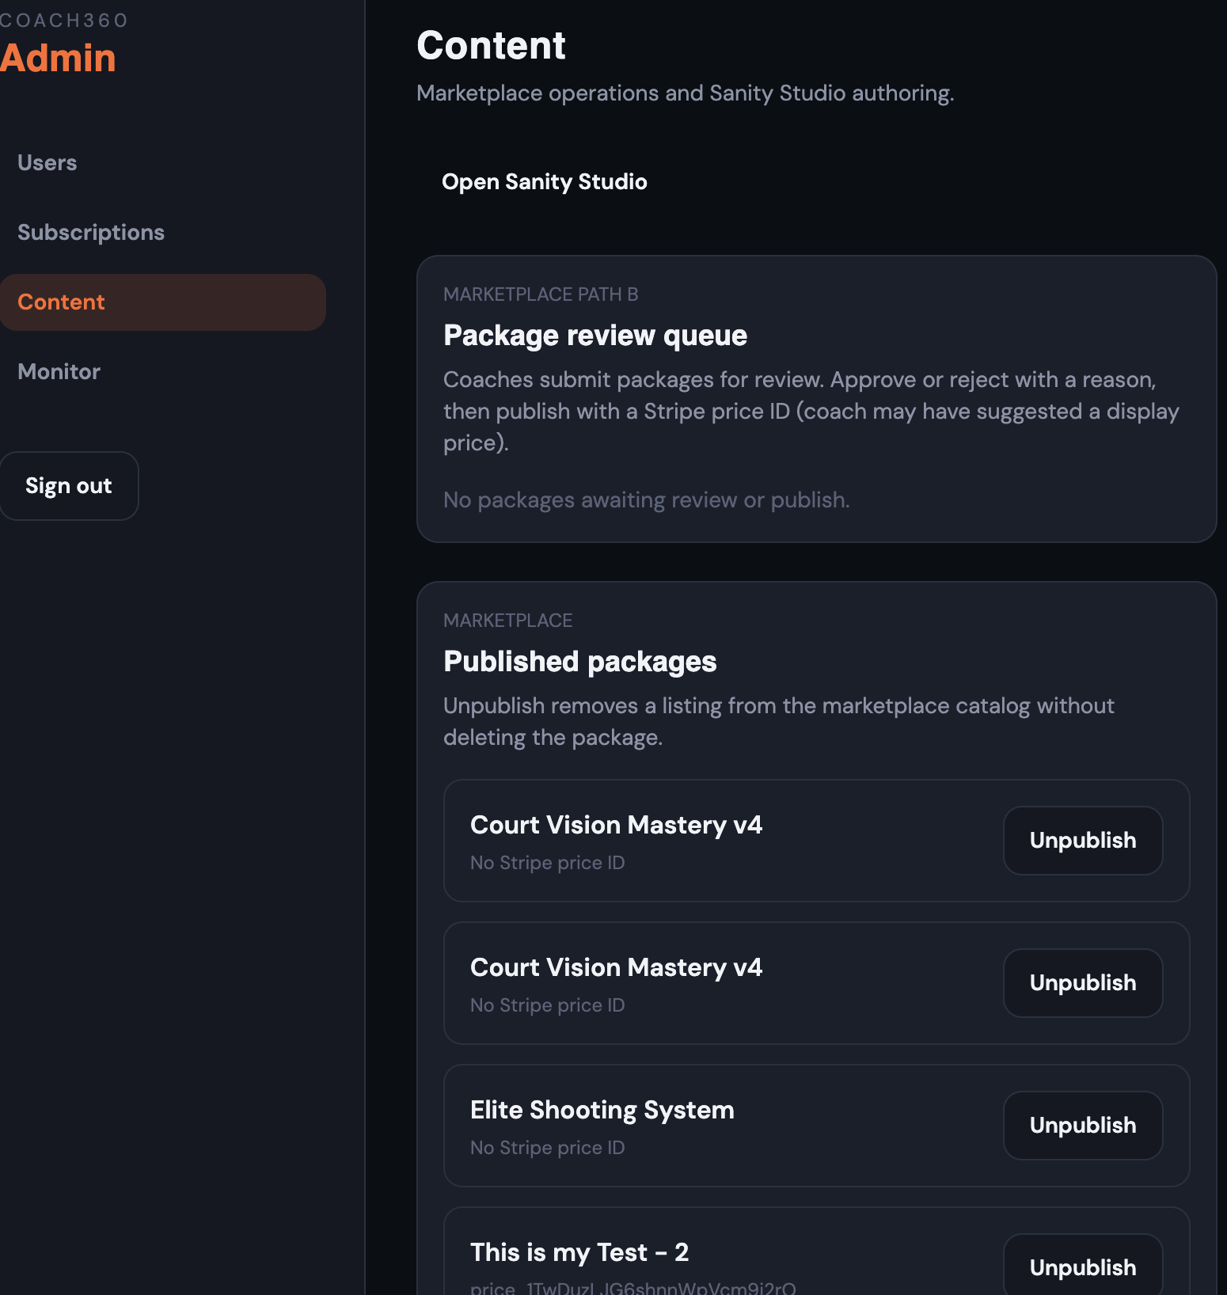
TEST ID:E10-T10
BUG: DEPENDENT BUG TO T10-E10

TEST ID: E10-T11
BUG: DEPENDENT BUG TO E10-E9
TEST ID: E12-T6
BUG: The field shows the same after save the default it did not change 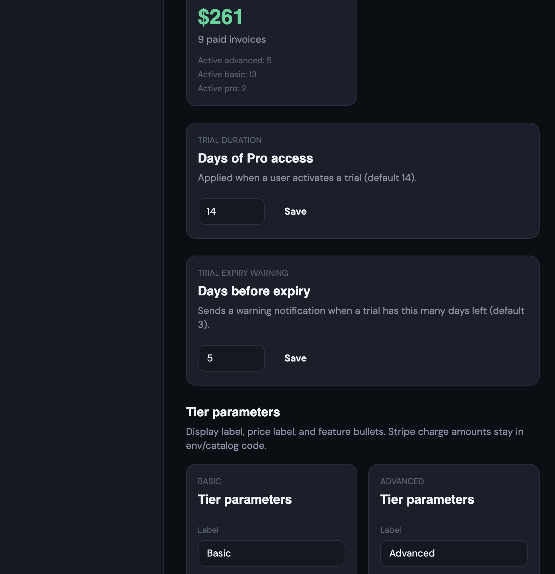

TEST ID: E12-T14
BUG: The package cannot leaves the review queue and di not appears under Published packages.
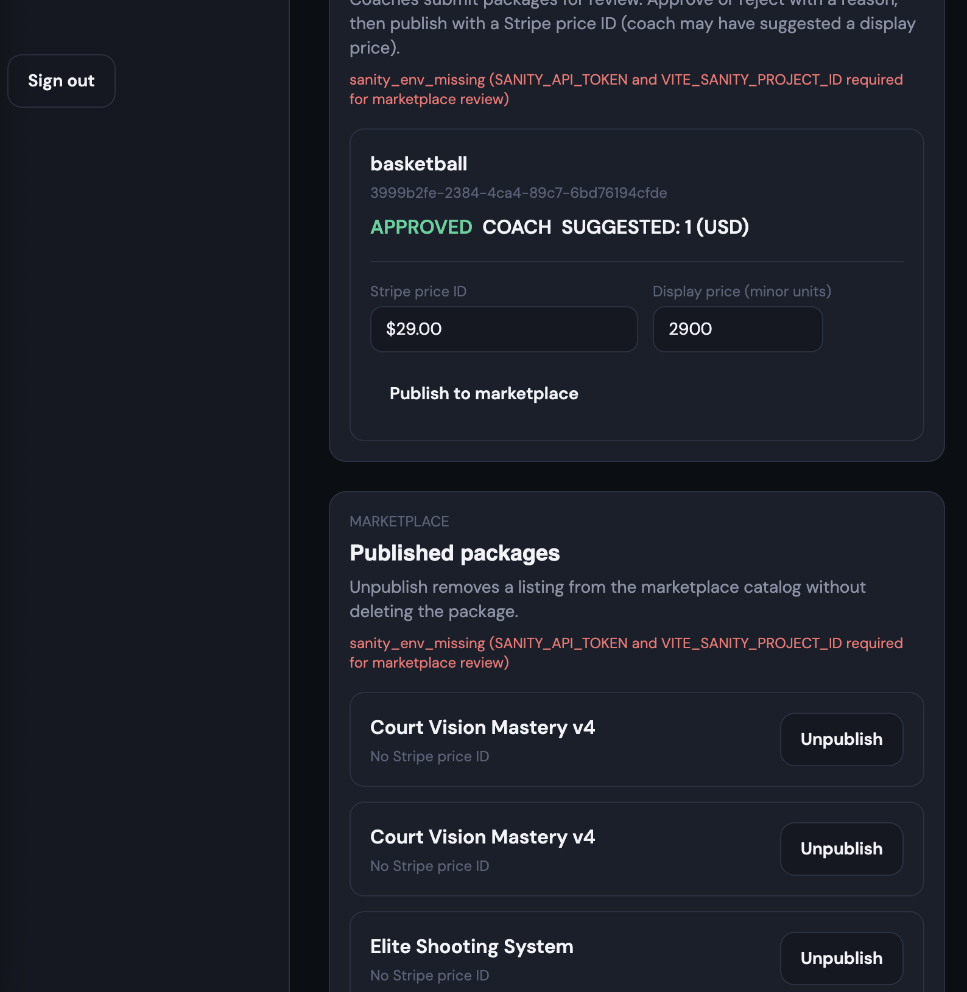

TEST ID: E12-T15
BUG: It does not remove the item from the Published list and may return it to the Review/Published path as Approved-Unpublished